**Basic Terminal Navigation Commands**

* **ls**: To get the list of all the files or folders.
* **ls -l:**Optional flags are added to **ls**to modify default behavior. Displays files in **long listing format** (permissions, owner, size, date, etc.) **-l**is used for **“long” output**
* **ls -a:**Shows **all** files, including hidden files (files starting with .), add **-a flag**
* **ls -h:** Shows file sizes in a human-readable format (KB, MB, GB instead of bytes).
* **ls -alh:** It is a combination of multiple options.
* **cd**: Used to change the directory.
* **du**: Show disk usage.
* **pwd**: Show the present working directory.
* **man**: Used to show the manual of any command present in Linux.
* **rmdir**: It is used to delete a directory if it is empty.
* **ln file1 file2**: Creates a physical link.
* **ln -s file1 file2**: Creates a symbolic link.
* **locate:**It is used to locate a file in Linux System
* **echo:**This command helps us move some data, usually text into a file.
* **df:**It is used to see the available disk space in each of the partitions in your system.
* **tar:**Used to work with tarballs (or files compressed in a tarball archive)
* **wc:** Used to count the number of characters, words in a file.
* **sort:** This command is used to sort the contents of files.
* **grep:** This command is used to search for the specified text in a file.
* **head:** Used to print the first N lines of a file. It accepts N as input and the default value of N is 10.
* **tail:** Used to print the last N-1 lines of a file. It accepts N as input and the default value of N is 10.
* **more:** It is a filter for paging through text one screenful at a time.
* **less:** It is used to viewing the files instead of opening the file. Similar to more command but it allows backward as well as forward movement.

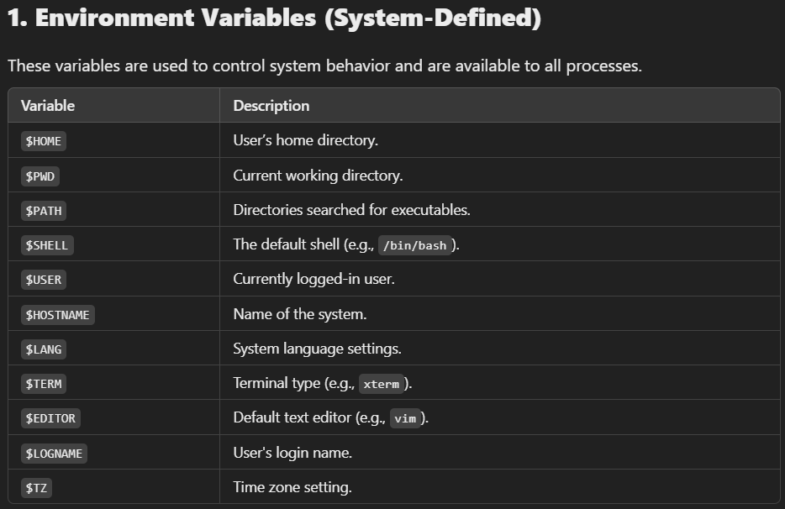

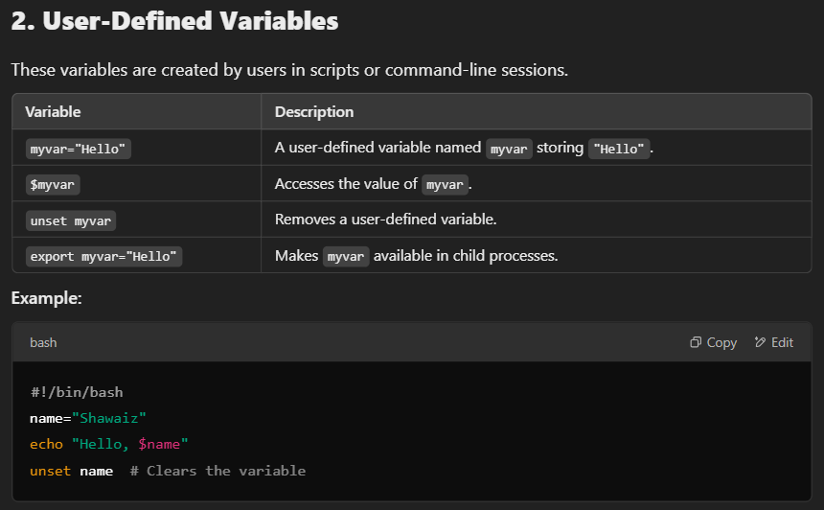

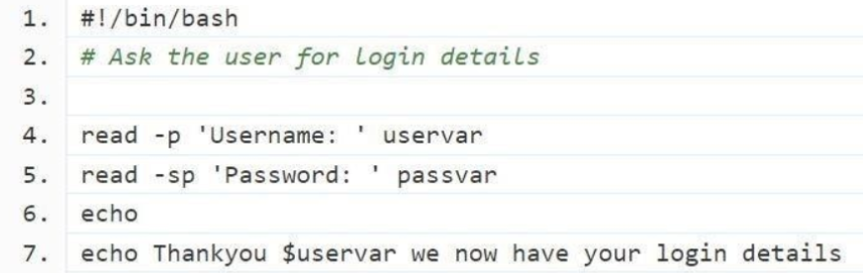

Two commonly used options however are **-p** which allows you to specify a prompt and **-s** which makes the input silent.

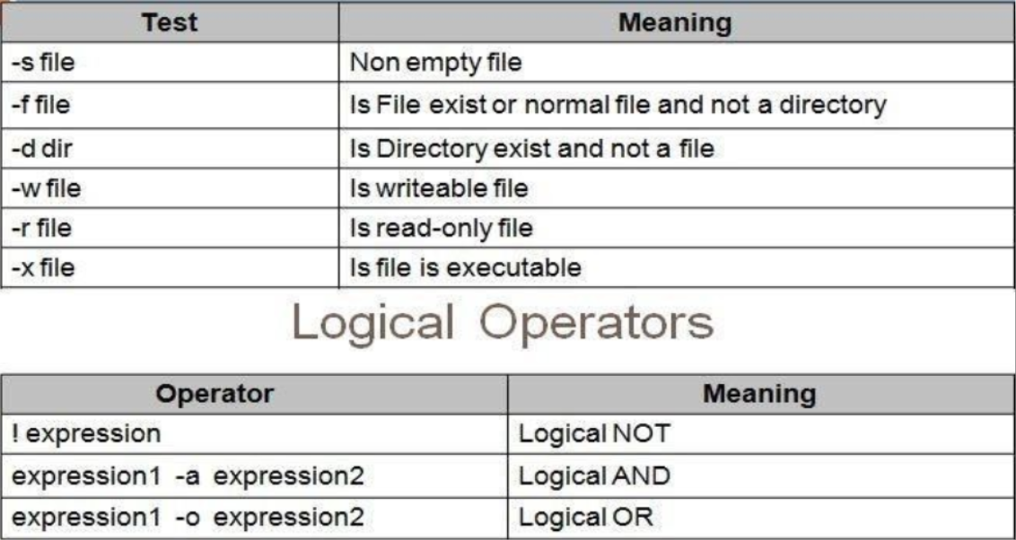

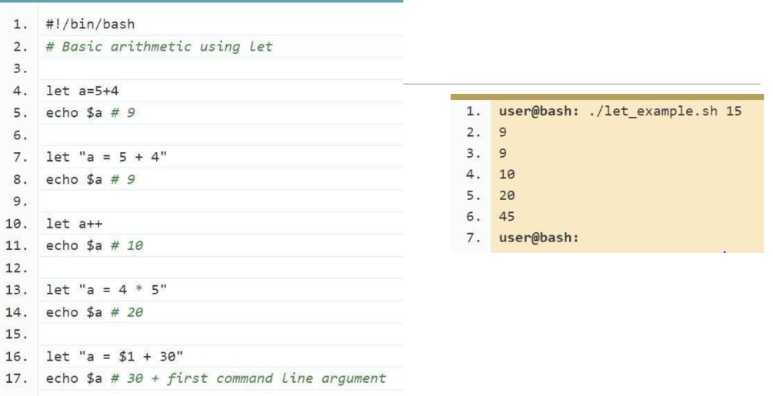

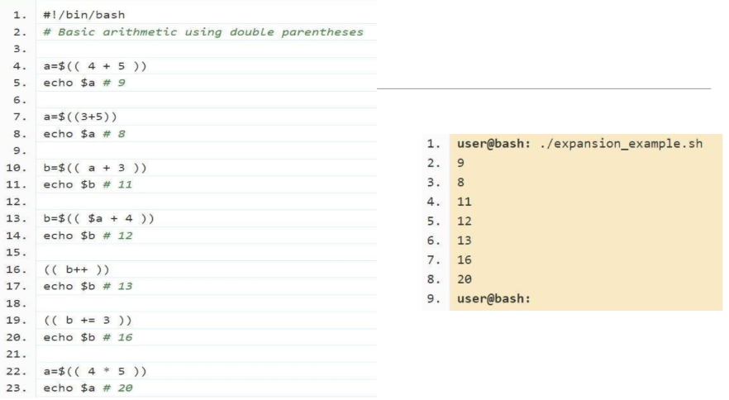

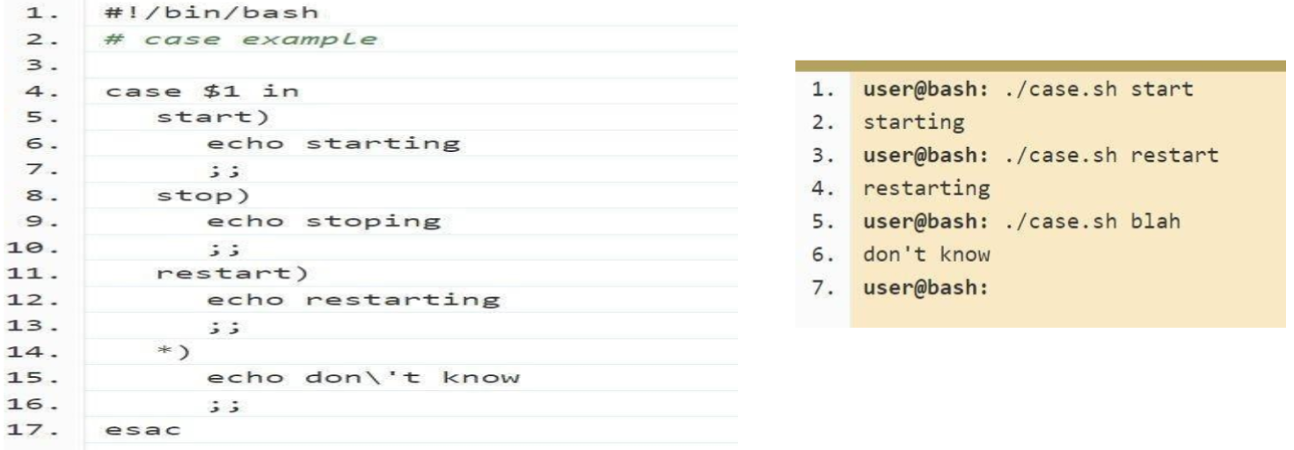

Loop until the condition is false, as soon as the condition becomes true, the loop exits.

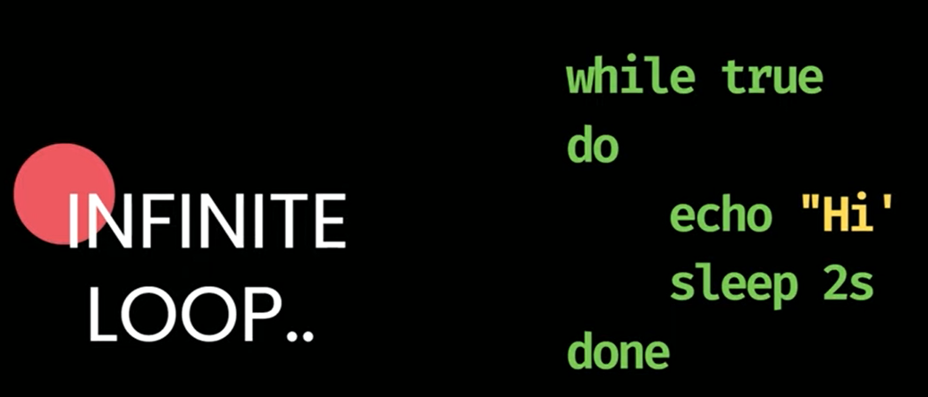

Ctrl + C to exit the infinite loop

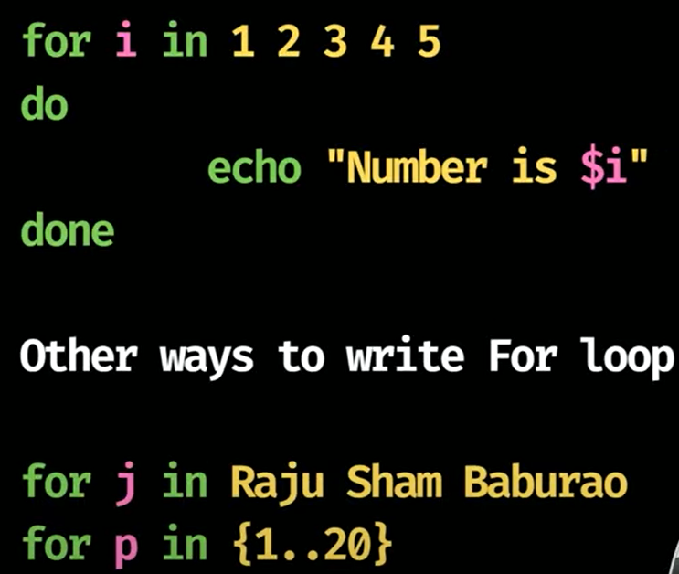1. Range in numbers

2. String range

3. Define range using wild card

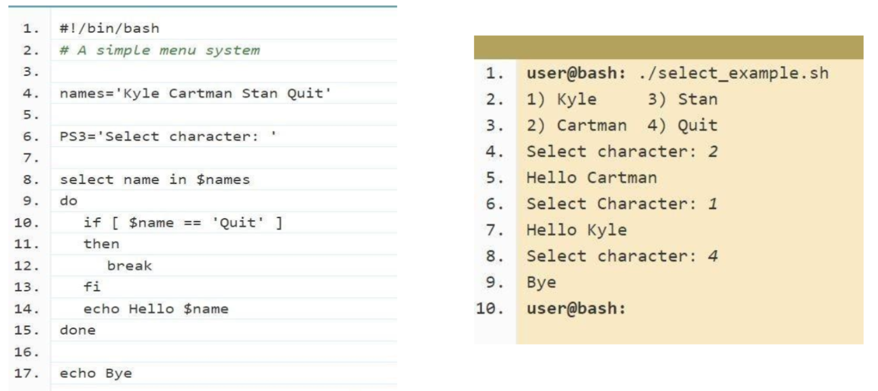

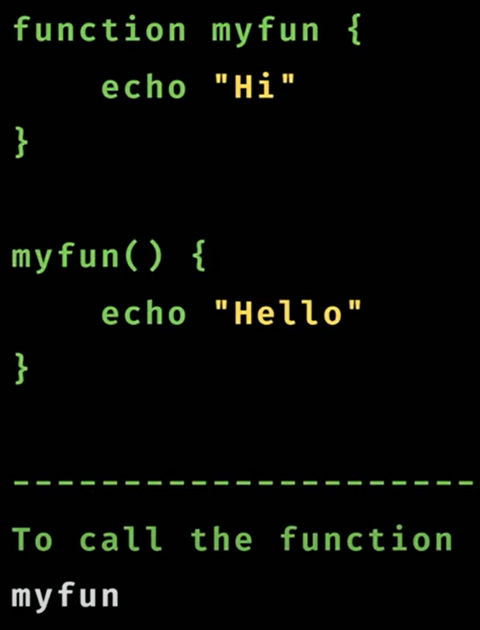

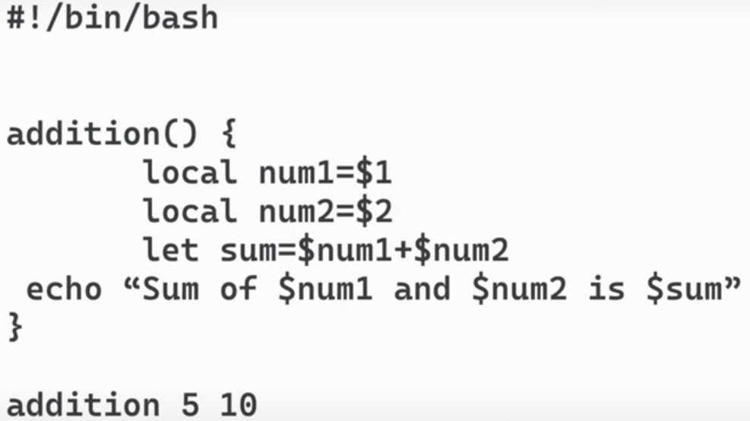

Show step by step whats happening in code.

